**The Need Of 3D Printing In Schools And Its Impact**

[**3D printing**](https://rapturize.in/3d-printing/) is all about enabling innovation, boosting creativity and alternative thinking among expressive and creative young generation. Today, innovation is not bounded by age or gender, but by the lack of resources, especially at school level. The young minds these days are full of innovative ideas and thoughts that are needed to be expressed, but the resource deficient option (access to necessary technology to implement the design) in schools make these ideas limited to the boundaries of their intelligent minds.

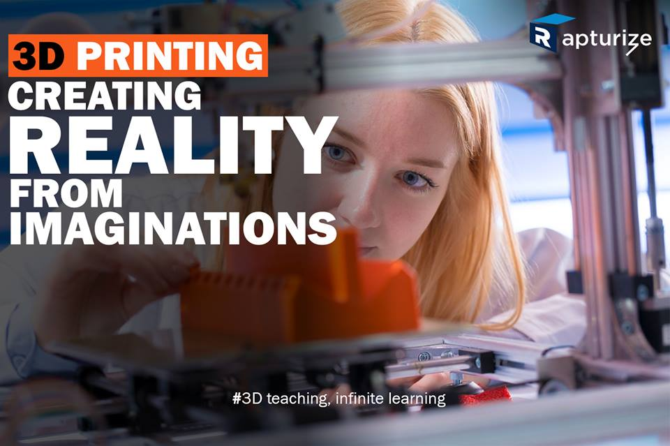

[**3D printing**](https://rapturize.in/3d-printing/) though might be a rough notion to many, but implementing it, viewing the drawbacks and possibilities makes it easier for the student to understand further possibilities of projecting their ideas to live ones. However vague it seems, but executing the [**3D printing in schools**](https://rapturize.in/3d-printing-in-schools/) will prove to be a very effective step that will transform the lives of next generation and help them to have education in a refined manner.

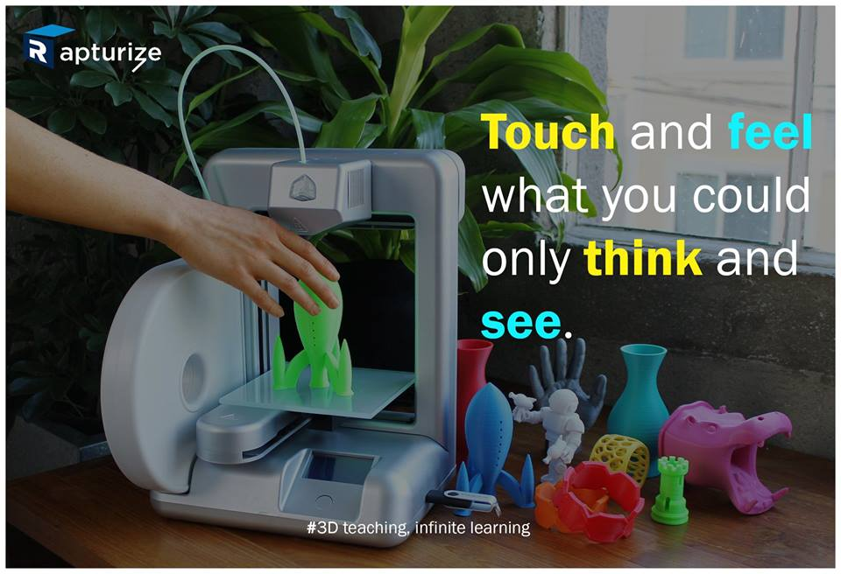

A student has so many thoughts and ideas spinning in his/her mind and the teachers wondering how these ideas could be bloomed to innovate something big. Perhaps a better computer or platform or a better technology can help process these thoughts. The [**3D Printing Labs in Schools**](https://rapturize.in/3d-printing-labs-in-schools/) is the best way to enable a better future, not for an individual alone but for the entire society for a better life. 3D printing technology provides a platform that helps a student jump a few steps ahead in their creative vision.

One can take the services of the [**Best 3D Printer Company in India**](http://rapturize.in/) who provide this great technology to make innovation & invention possible for young minds. This great technology provide ways to incorporate interactive learning into the classroom which means –

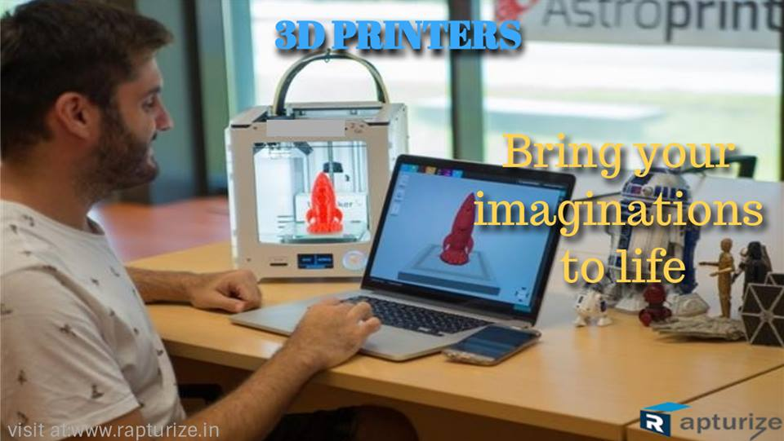

* Biology students can study cross-sections of hearts or other body organs.
* Graphic design students can fashion prototypes of product designs.
* Design and Engineering students can construct prototypes of their creations.
* Chemistry students can print out complex molecules to study.
* Architectural students can print new or existing designs.
* History classes can print artifacts for closer examination.
* Engineering students can print modified car or robot parts.
* Geometry students can print out topography, population or demographics of a region.
* Food Technology students can devise moulds and cookie cutter templates.

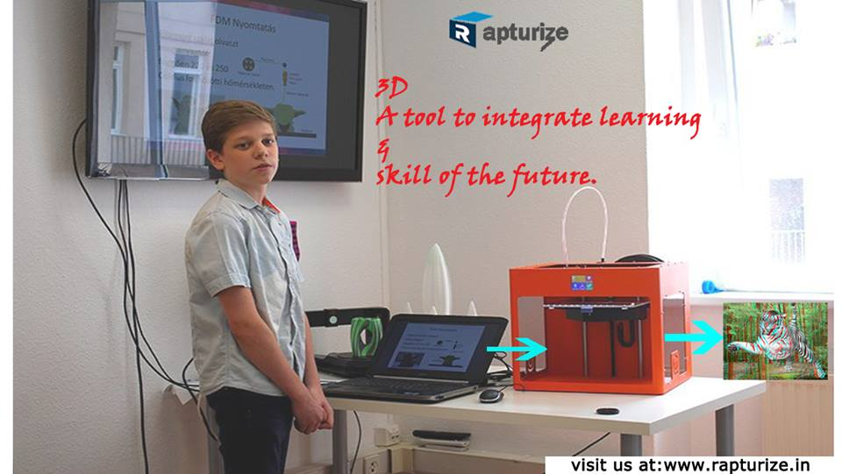

So, with their services, one can introduce inventive learning using 3D printer workshops and classrooms. Furthermore, these 3D printing services providers also provide the most advanced 3d printing products and services in India. They offer **Best 3D Printer Company in India**, **3D Printing Labs in Schools**, **3d Printing In Schools**, **3d Printing In Colleges**, **3d Printing Labs**, **Best 3d Printer In India**, **Atal Tinkering Labs In Schools**, **3d Printing In Education**, **3d Printing Services In India**, and **3d Printing** services that are available in **Rapturize**. Its powerful digital thread empowers professionals, students, and individuals everywhere to bring their ideas to life in material choices including plastics, metals, resin, silicon, ceramics and edibles, empowering customers to imagine, design and makes their future.